Assignment 3

Student Name: Priyanshu
Enrollment/Roll Number: IoT-029
Course Name: Internet of Things (IoT)
Assignment Title:
Submission Date:

Ans35.
WeatherFetcher.ino
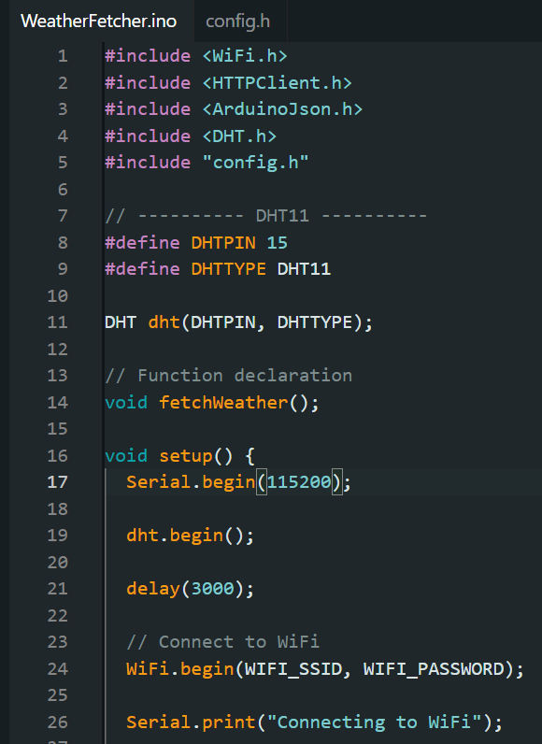
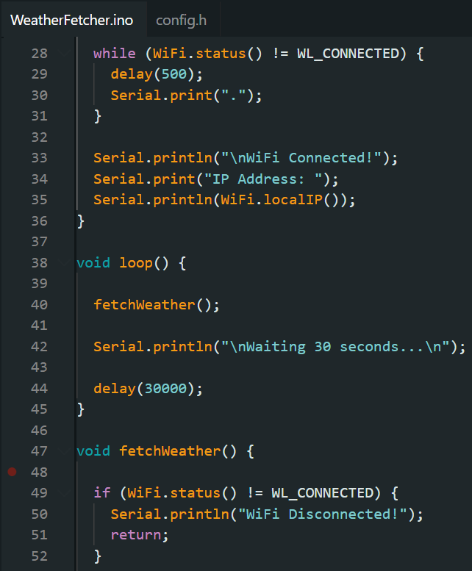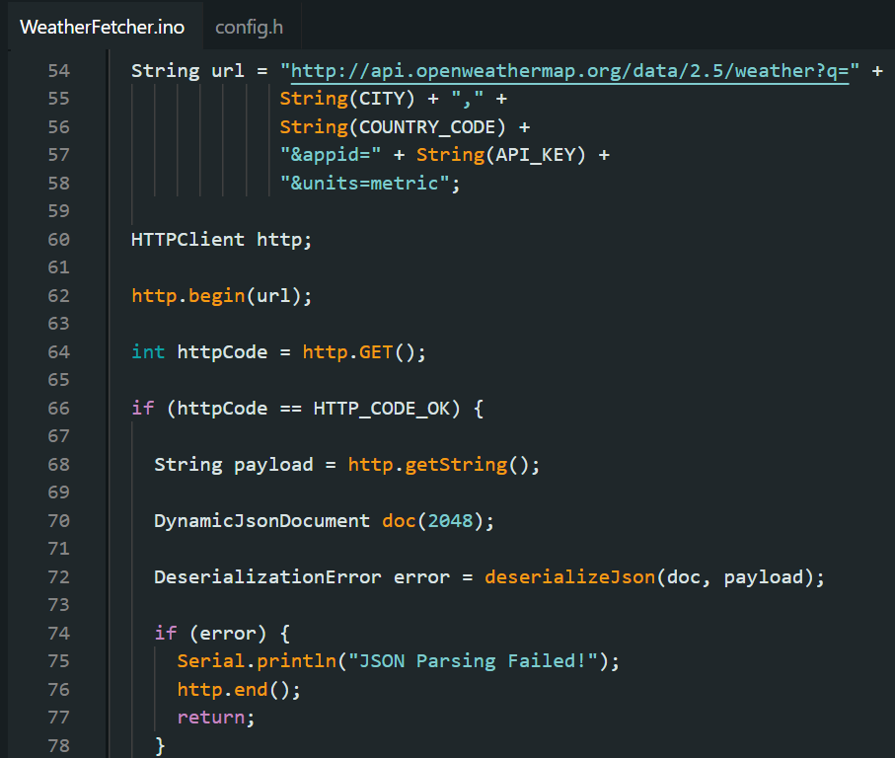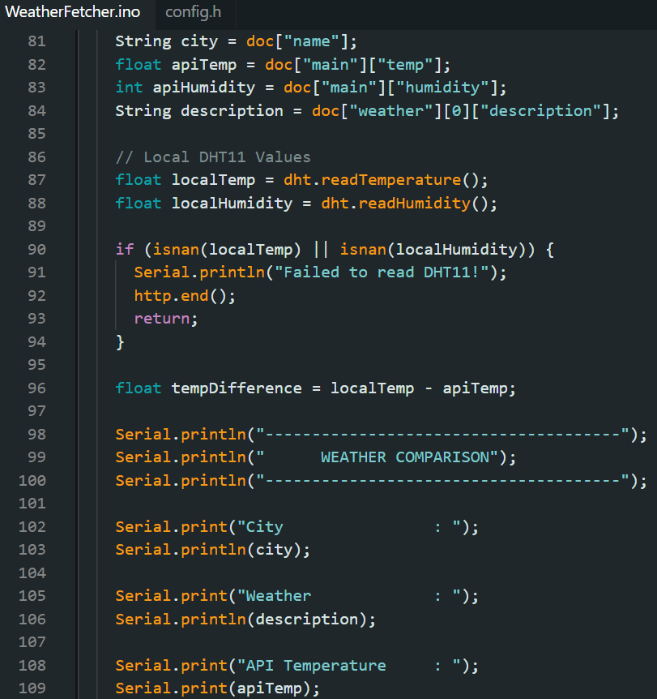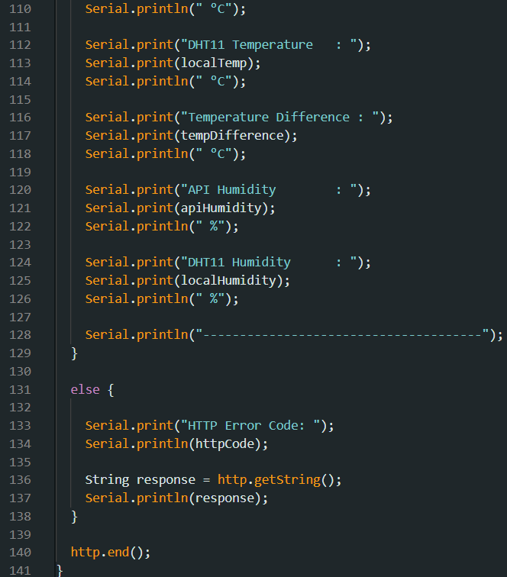

Config.h
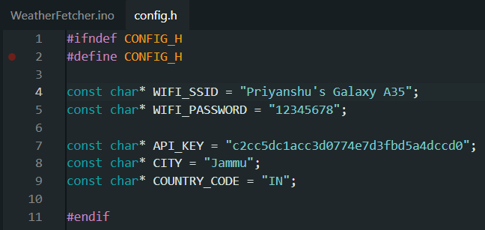

Output
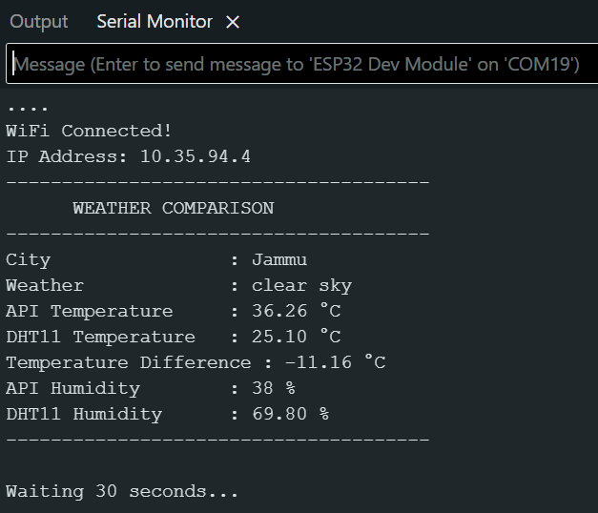

Ans36.
Feature | MQTT | HTTP
Architecture Pattern | Publish/Subscribe using a broker | Client/Server (Request-Response)
Data Transfer Model | Sends data only when required through topics | Client sends a request and waits for a response
Power Consumption | Low power consumption | Higher power consumption
Latency | Very low latency | Higher latency compared to MQTT
Use Case Suitability for IoT | Excellent for IoT devices, sensors, and real-time monitoring | Better for web applications, APIs, and occasional data exchange
Security Considerations | Supports TLS/SSL encryption, authentication, and access control through the broker | Supports HTTPS (SSL/TLS), authentication, and secure APIs

For a 1000-node smart agriculture system, I would choose MQTT.
Reason:
- It uses very little bandwidth, making it suitable for large numbers of sensor nodes.
- It consumes less power, which helps battery-operated devices last longer.
- It provides low latency, allowing quick delivery of sensor readings and alerts.
- The publish/subscribe model makes communication efficient because devices only receive the data they subscribe to.
- A single MQTT broker can efficiently manage communication among thousands of devices, making the system scalable.

Ans37.
Wi-Fi security is very important in IoT because most smart devices send and receive data over the internet. If the network is not secure, attackers can steal information or even take control of the devices. One common attack is based on WPA2 vulnerabilities. Although WPA2 is a secure Wi-Fi standard, some weaknesses, such as the KRACK attack, have shown that attackers can exploit devices that have not been updated with security patches.
Another common attack is the Evil Twin attack. In this attack, a hacker creates a fake Wi-Fi network with the same name as a real one. If an IoT device connects to this fake network, the attacker may be able to capture data or steal login credentials.
To make ESP32 devices more secure, developers should use WPA3 whenever possible because it provides better protection than WPA2. It is also a good idea to use TLS encryption with certificate pinning, so the ESP32 communicates only with trusted servers. Keeping the firmware updated, using strong passwords, and disabling unnecessary services also improve security.
Hardcoding Wi-Fi passwords or API keys directly into the source code is risky. If someone gets access to the code or uploads it to a public GitHub repository, anyone can see those credentials and misuse them. A better approach is to store passwords in a separate configuration file or use secure storage, and never upload sensitive information to public repositories.

Ans38.
LPWAN stands for Low Power Wide Area Network. It is a type of wireless network designed for IoT devices that need to send small amounts of data over long distances while using very little battery power. LPWAN is commonly used in smart agriculture, smart cities, environmental monitoring, and asset tracking because devices can operate for several years on a single battery.
LoRa is one of the most popular LPWAN technologies. It achieves long-range communication by using a technique called the Spreading Factor (SF). A higher spreading factor allows the signal to travel farther and improves communication in areas with weak signal strength. Although increasing the spreading factor reduces the data transmission speed, it helps maintain reliable communication over long distances while keeping power consumption low.
When compared with other wireless technologies, LoRa provides the longest communication range, often several kilometers, and is suitable for outdoor IoT applications. Zigbee has a shorter range but supports mesh networking, making it useful for home automation and industrial control. Z-Wave is mainly used in smart home devices and also has a shorter range than LoRa.
A real-world example in India is the use of LoRa-based smart agriculture solutions in states such as Maharashtra and Karnataka. Farmers use LoRa sensors to monitor soil moisture, temperature, and water levels in their fields. The collected data helps them make better irrigation decisions, reduce water wastage, and improve crop productivity.

Ans39.
An IoT gateway is a device that acts as a bridge between IoT sensor nodes and the cloud. It collects data from sensors, processes or filters it if needed, and then sends it to the cloud. It can also receive commands from the cloud and forward them to the connected IoT devices. An IoT gateway improves security, reduces network traffic, and allows devices using different communication protocols to work together.
Diagram
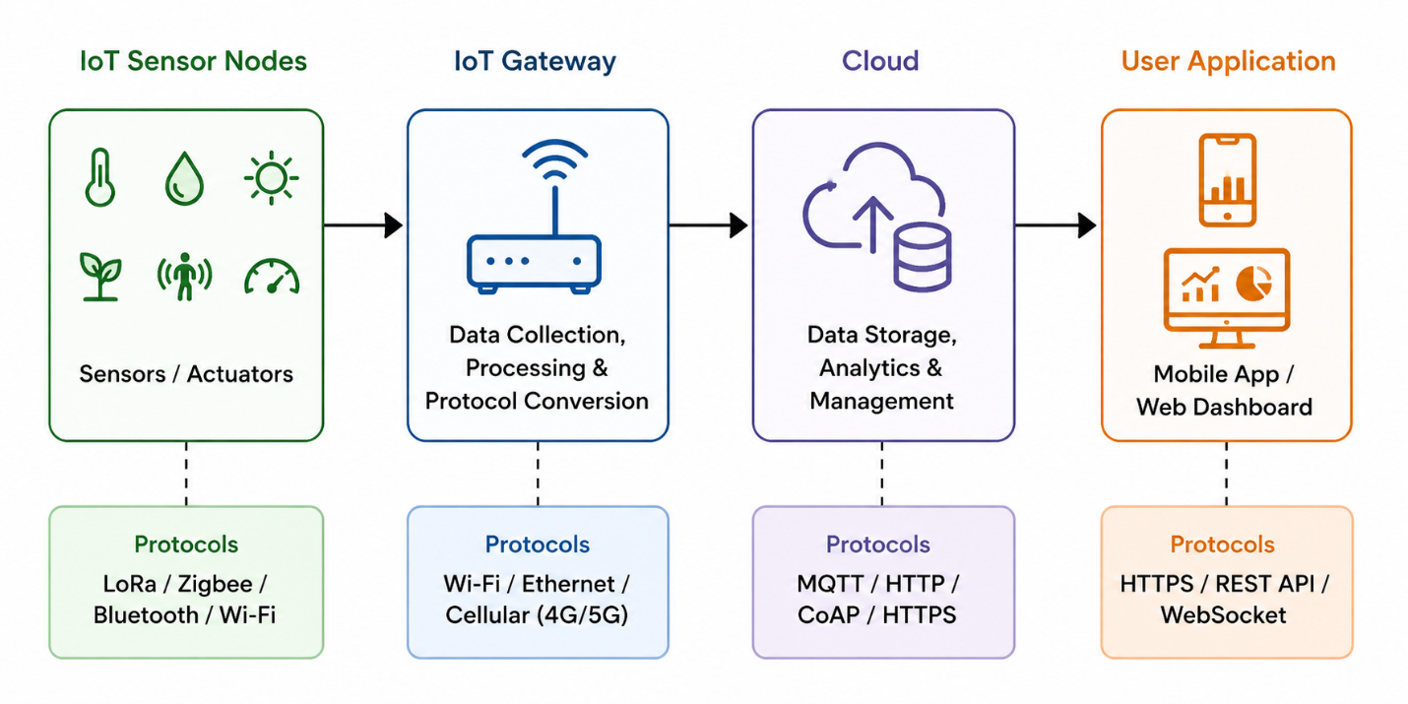
Protocols Used at Each Layer
Layer | Common Protocols
IoT Sensor Nodes → Gateway | LoRa, Zigbee, Bluetooth, Wi-Fi
Gateway → Cloud | MQTT, HTTP/HTTPS, CoAP
Cloud → User Application | HTTPS, REST API, WebSocket

Ans40.
QoS (Quality of Service) in MQTT defines how reliably a message is delivered between the publisher and the subscriber. MQTT provides three QoS levels.
QoS 0 – At Most Once
The message is sent only once without any confirmation from the receiver. If the message is lost, it is not sent again. This is the fastest method and uses the least bandwidth, but delivery is not guaranteed.
QoS 1 – At Least Once
The sender waits for an acknowledgment from the receiver. If no acknowledgment is received, the message is sent again. This guarantees that the message reaches the receiver, but it may be delivered more than once.
QoS 2 – Exactly Once
This is the highest level of reliability. It uses a four-step handshake to ensure that the message is delivered only once. It is slower and consumes more bandwidth but prevents duplicate messages.
For an IoT water level monitoring system, I would choose QoS 1
Reason:
In a water level monitoring system, it is important that sensor readings reach the server reliably. If a reading is accidentally sent twice, it usually does not cause a major problem because the latest value can be processed. However, losing a water level reading could result in incorrect monitoring or delayed alerts. QoS 1 provides a good balance between reliability, speed, and network usage, making it the most suitable choice for this application.

